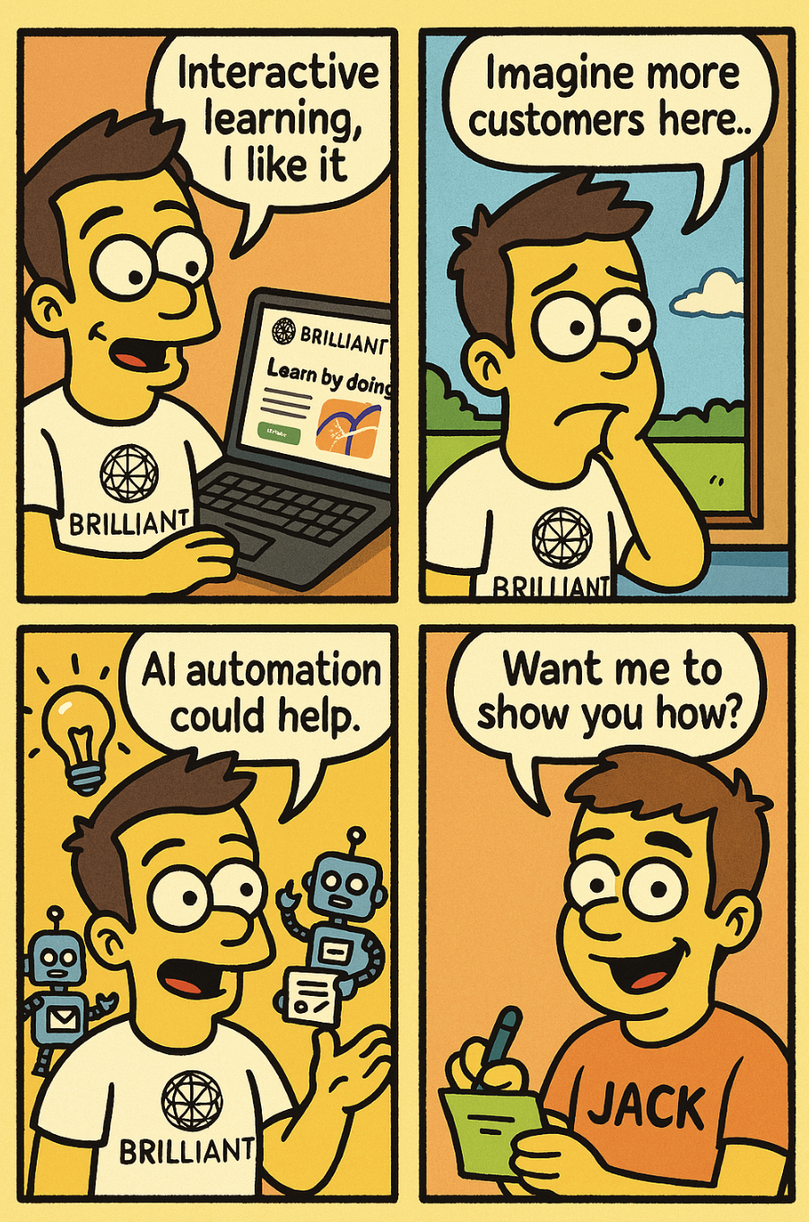
🎨 Comic Outreach Lead Magnet (4-Panel)

Create a 4-panel comic strip in a vibrant, cartoon style reminiscent of classic animated sitcoms: bold outlines, exaggerated facial expressions, and a bright, playful color palette. The characters should have yellow skin tones, expressive eyes, and a slightly caricatured look.
The main character is a tech-savvy, confident professional with either a clean haircut or a scruffy beard (Character A). Character A wears a T-shirt featuring the attached logo. Character B appears in the last strip (part 4) looks different, and has a different t-shirt on with the word INSERT YOUR NAME; written on it.
This comic will be used as a creative cold outreach for an AI automation consultant.

✅ Visual Style Notes:
- Yellow-toned skin, cartoonish proportions
- Thick black outlines, bright colors
- Exaggerated facial expressions
- Clean, punchy composition
- Every single panel MUST have a speech bubble as explain below.

Accent colors and props reflecting the brand. The brand colours and description of the homepage to include are:
{{ $('Website Analysis').item.json.content }}
Keep the design visually beautiful with contrasting colours.
Include a website screenshot on the laptop screen in panel 1.

✅ Text & Structure:
- Max 5 words per panel, in speech bubbles or notes only
- Style and tone: humorous, insightful, friendly

🟨 Panel Breakdown
Panel 1 – Admiration
Scene: Character A is looking at his open laptop and the attached screenshot is clearly visible.
The business website clearly visible. He looks intrigued
Speech bubble:
""{{ $json.message.content }}""

Panel 2 – Opportunity Thought
Scene: Character A wonders longingly looking out of the window as he considers. He looks sad.
Speech bubble:
"Imagine more customers here..."

Panel 3 – Insight
Scene: A lightbulb appears above Character A's head. In the background, helpful cartoon robots tidy tabs, auto-sort messages, or serve digital forms. He looks hopeful.
Speech bubble:
"AI Automation could help."

Panel 4 – CTA
Scene: A New character (Character B) in the fourth panel, visibly different then the others with a plain shirt with the word Jack on it. He smiles, writing on a sticky note or messaging box.

Message:
"Want me to show you how?"

